**DocuSign Template Setup**

* Create account in DocuSign

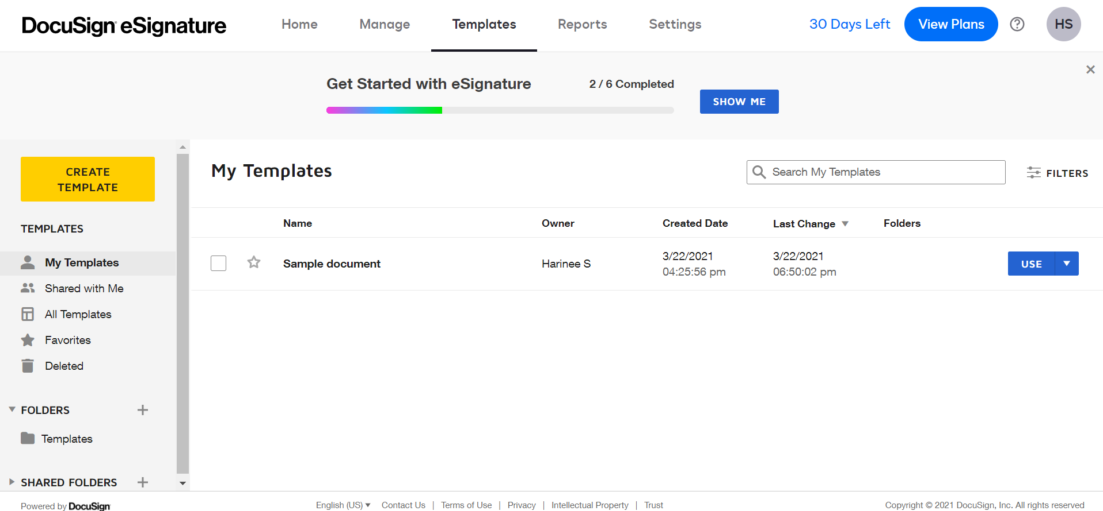

* Add that account in DocuSign setup tab

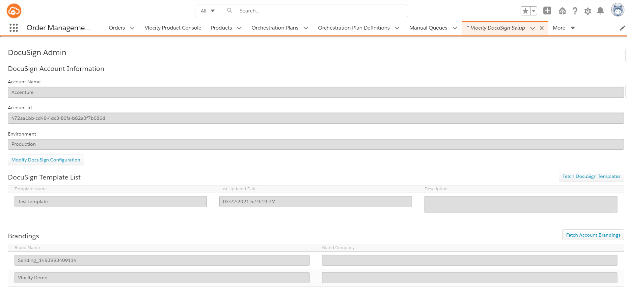

* Configure the correct Remote Site Settings

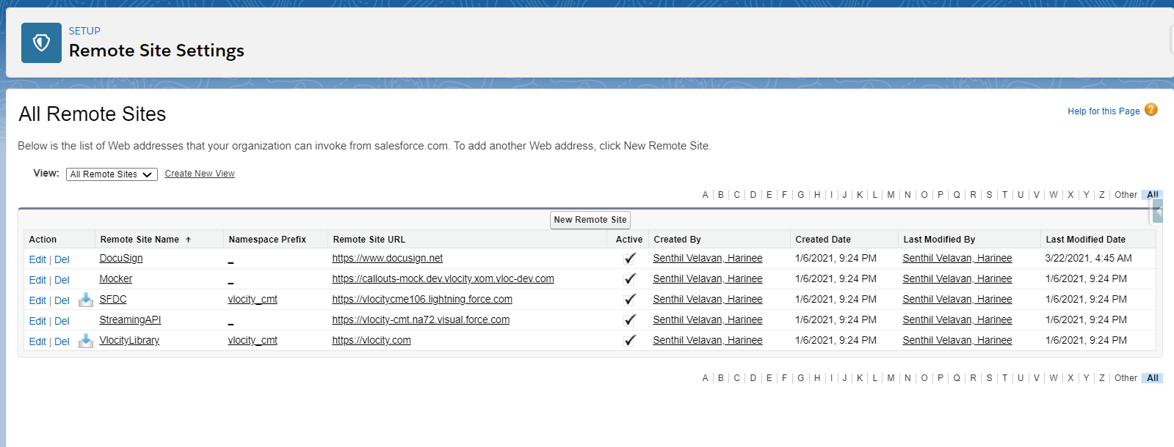

* Install the Docusign managed package

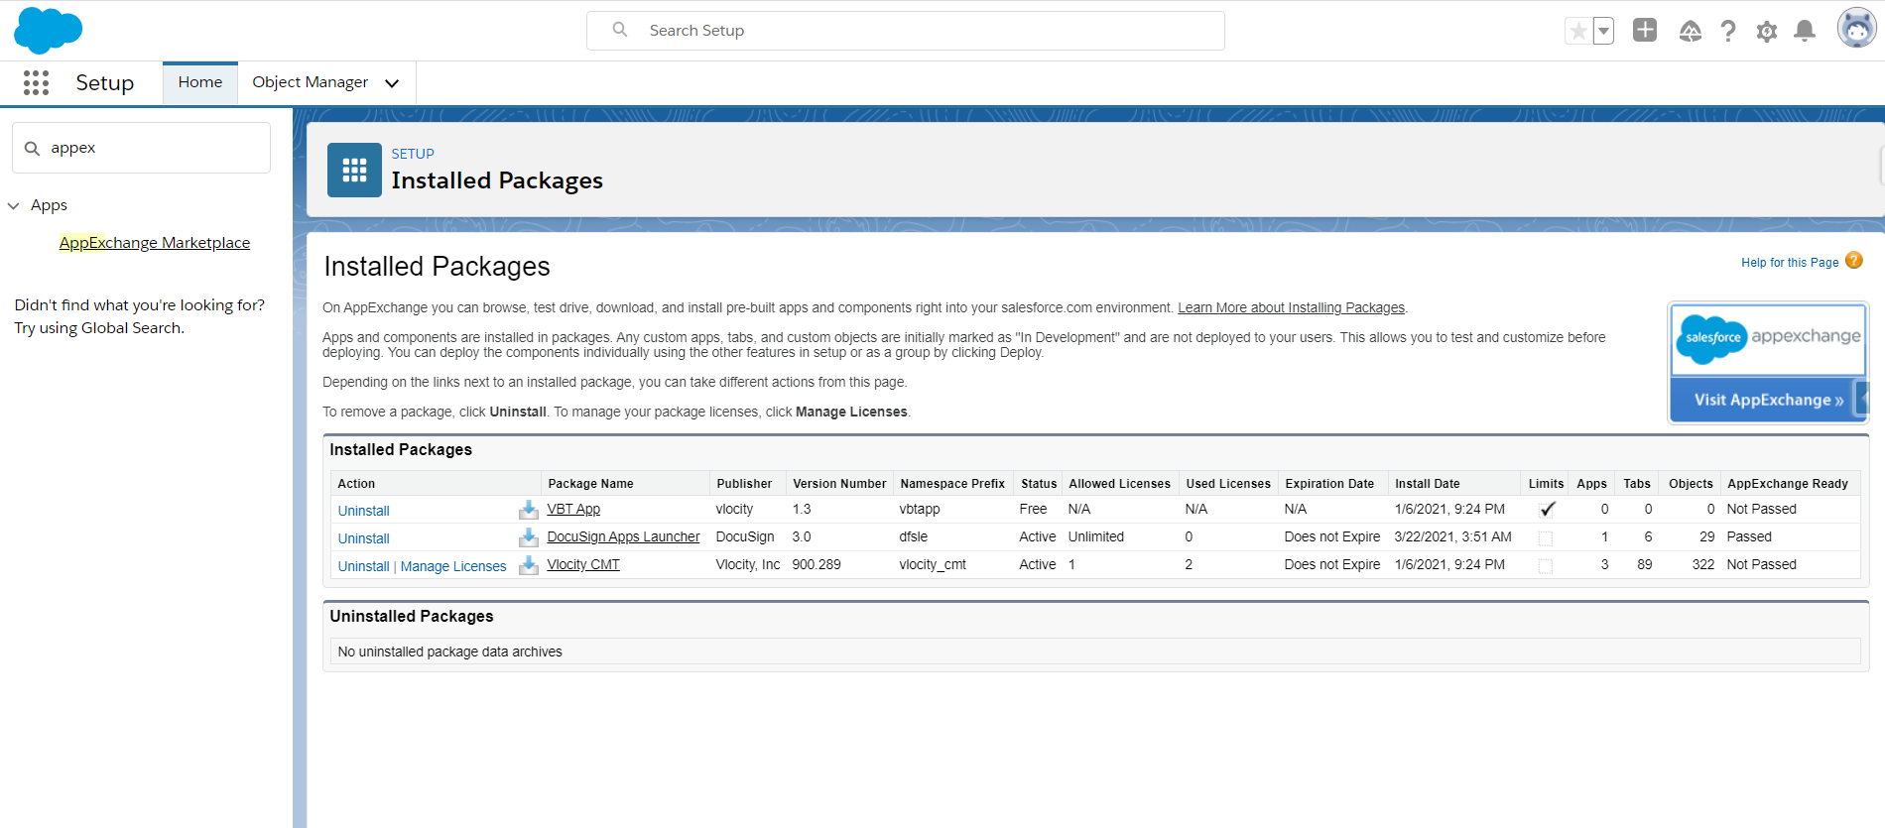

* Create a Vlocity Docusign Template

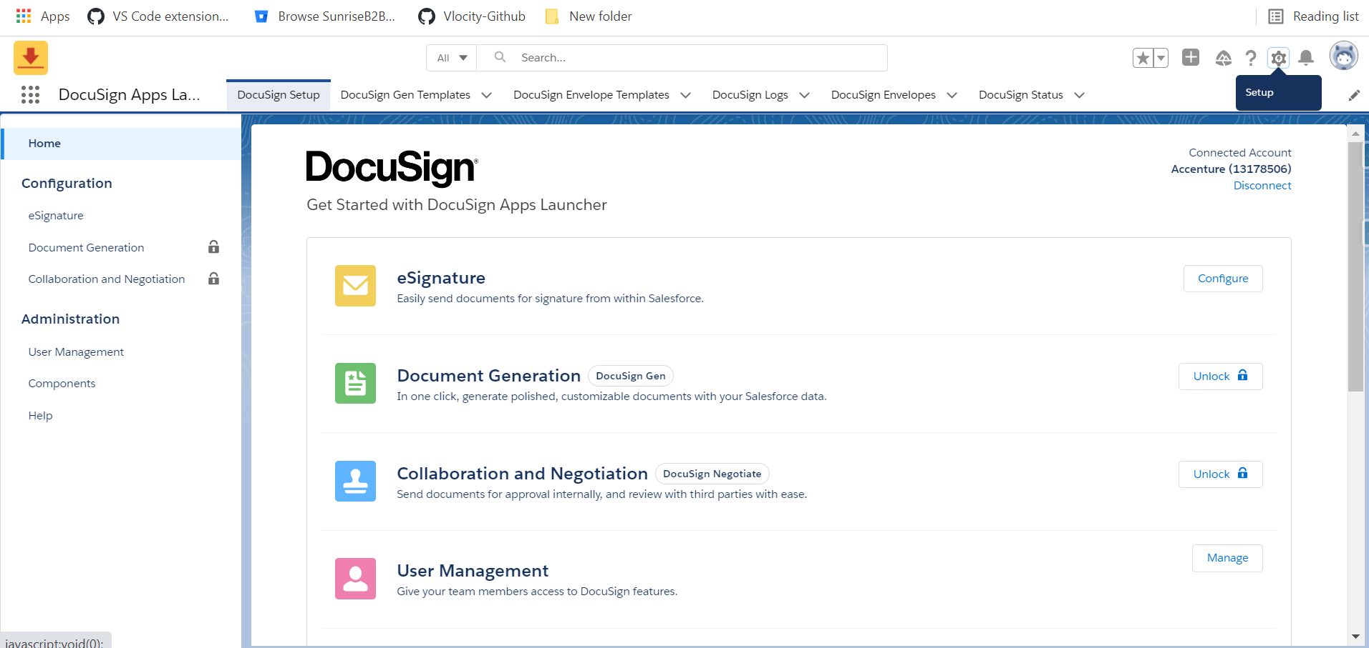

* Click on Configure

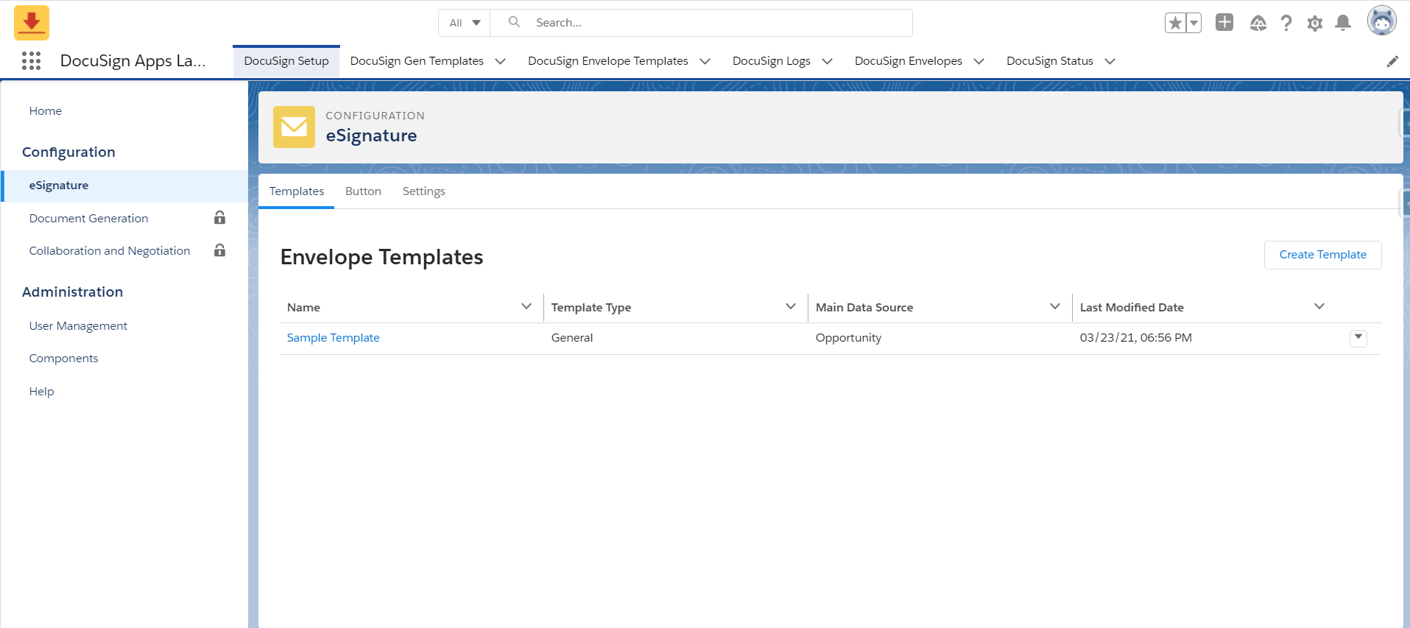

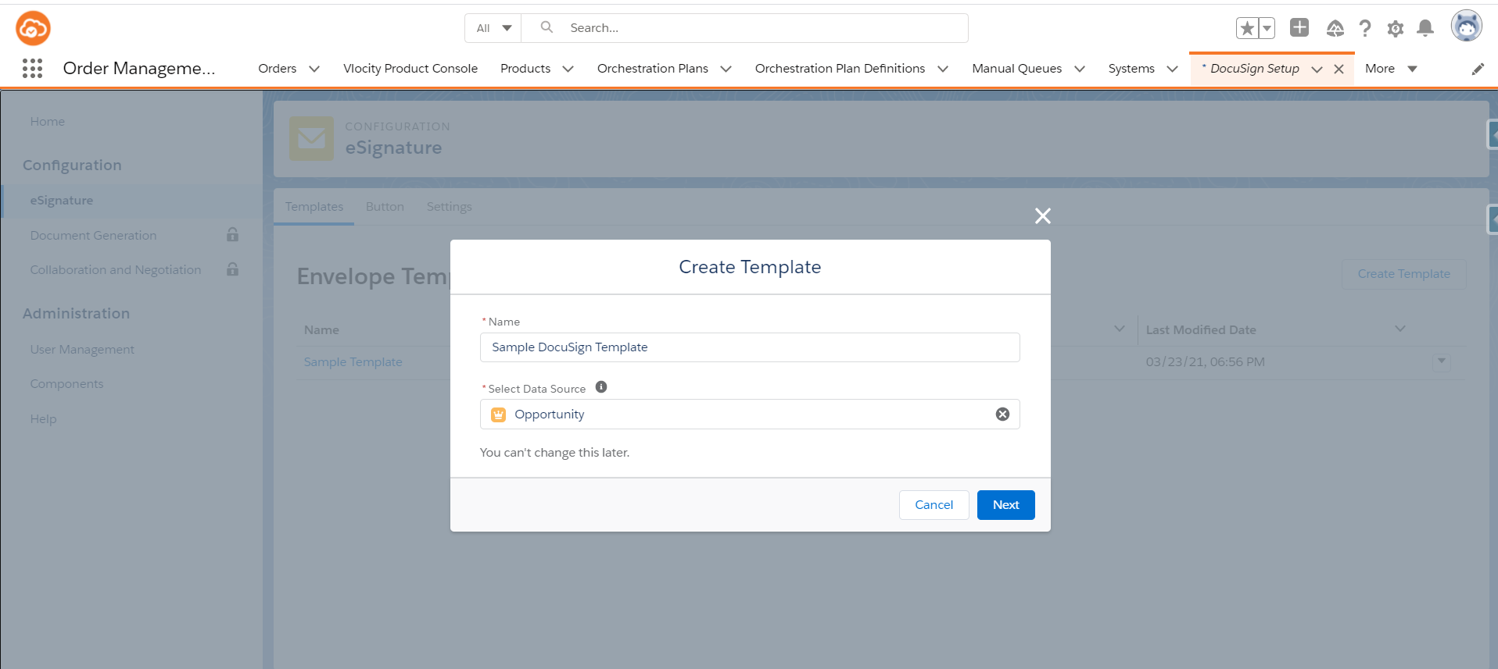

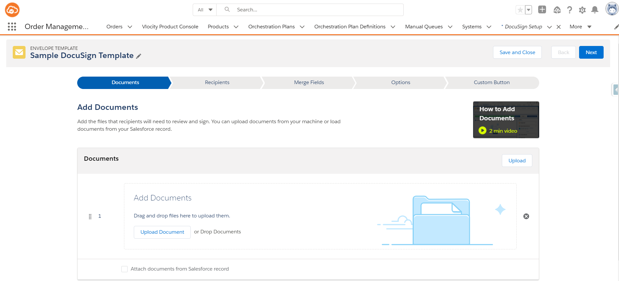

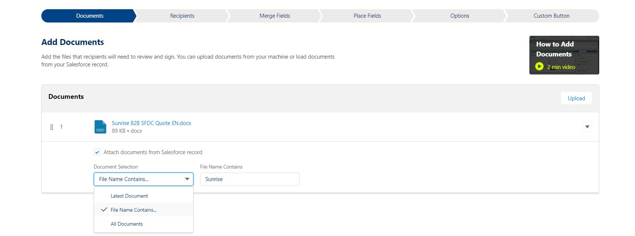

**You have the Option to select the document either from your System or through Document Selection.**

1. Latest Document – It will fetch the latest document from the Salesforce record
2. File Name Contains - Here you can give the contained Name in the file which will fetch the required file
3. All Documents - This option will fetch all the documents.

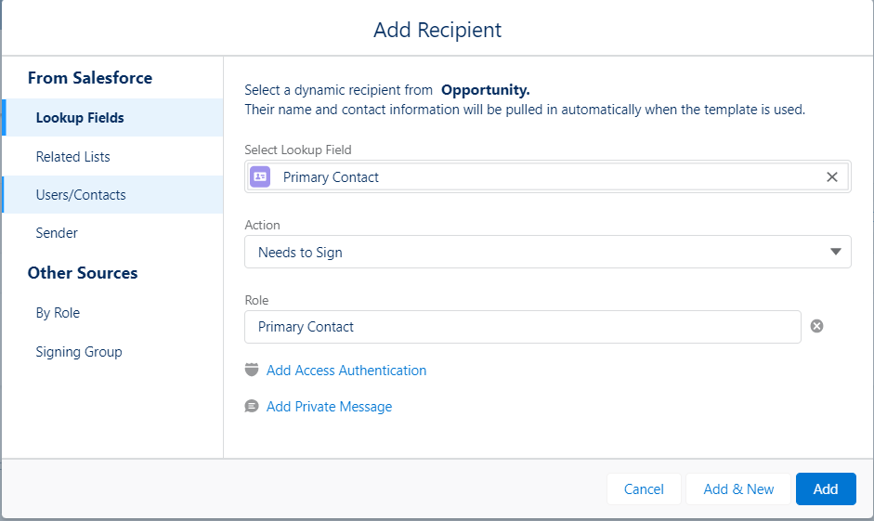

In the Add recipient field, you can add the 4 fields from Salesforce namely

1. Lookup Fields
2. Related Lists
3. Users/Contacts
4. Sender

Here we’ve selected the Lookup field, which we’ll dynamically take the name as the lookup value and update it in the recipient list.

We’ve created a Lookup field Called “Primary Contact” in Opportunity Salesforce Object which will take the contact field as the lookup Value.

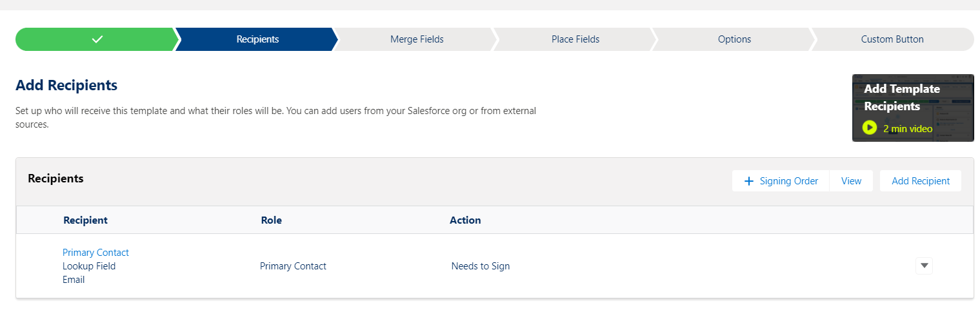

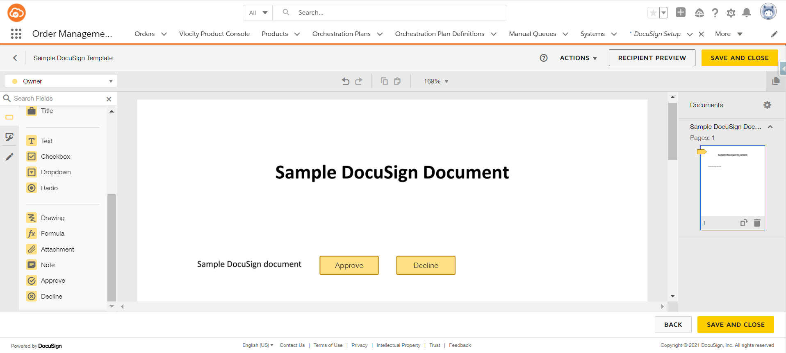

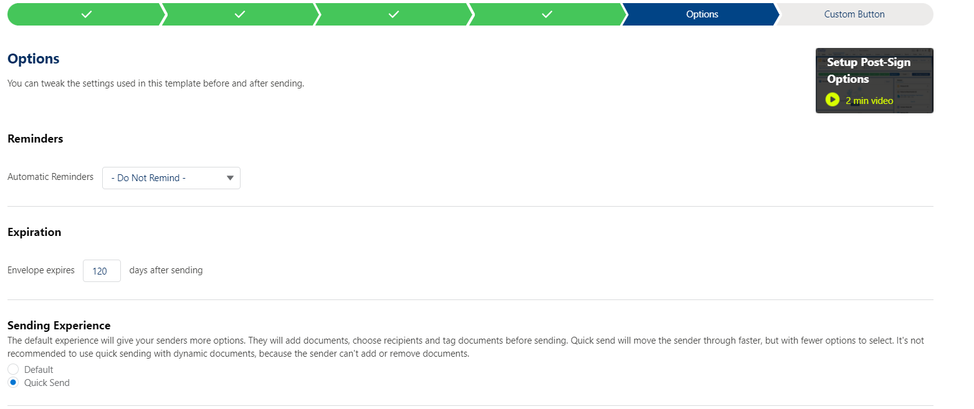

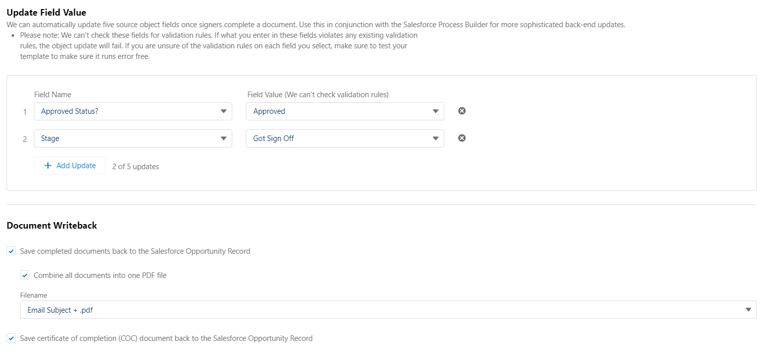

You can add Options to your template

1. Reminders – You can set the automatics reminders from the dropdown options
2. Expiration – You can select the no. of days for the envelope to expire after sending
3. Sending Experience - Here you get two options
4. Default
5. Quick Send
6. Update Field Value – Here you can update 5 source field values once the document is signed.

**Note: Upto 5 Source field Object fields can be updated**

**For the testing purpose, we’ve created the custom picklist value field with two options in salesforce Opportunity Object.**

1. **Not Approved (Default Value)**
2. **Approved**
3. **We’ve created the additional stage named “Got Sign Off” and included that in the Stage field in opportunity object**.
4. Document Writeback - Here you get the option of storing the signed document back to Opportunity records in the notes and attachment field.
5. If you don’t want to see the attached fields in the layout, then you need to remove that from the page layout but it will be available at the backend for internal use.

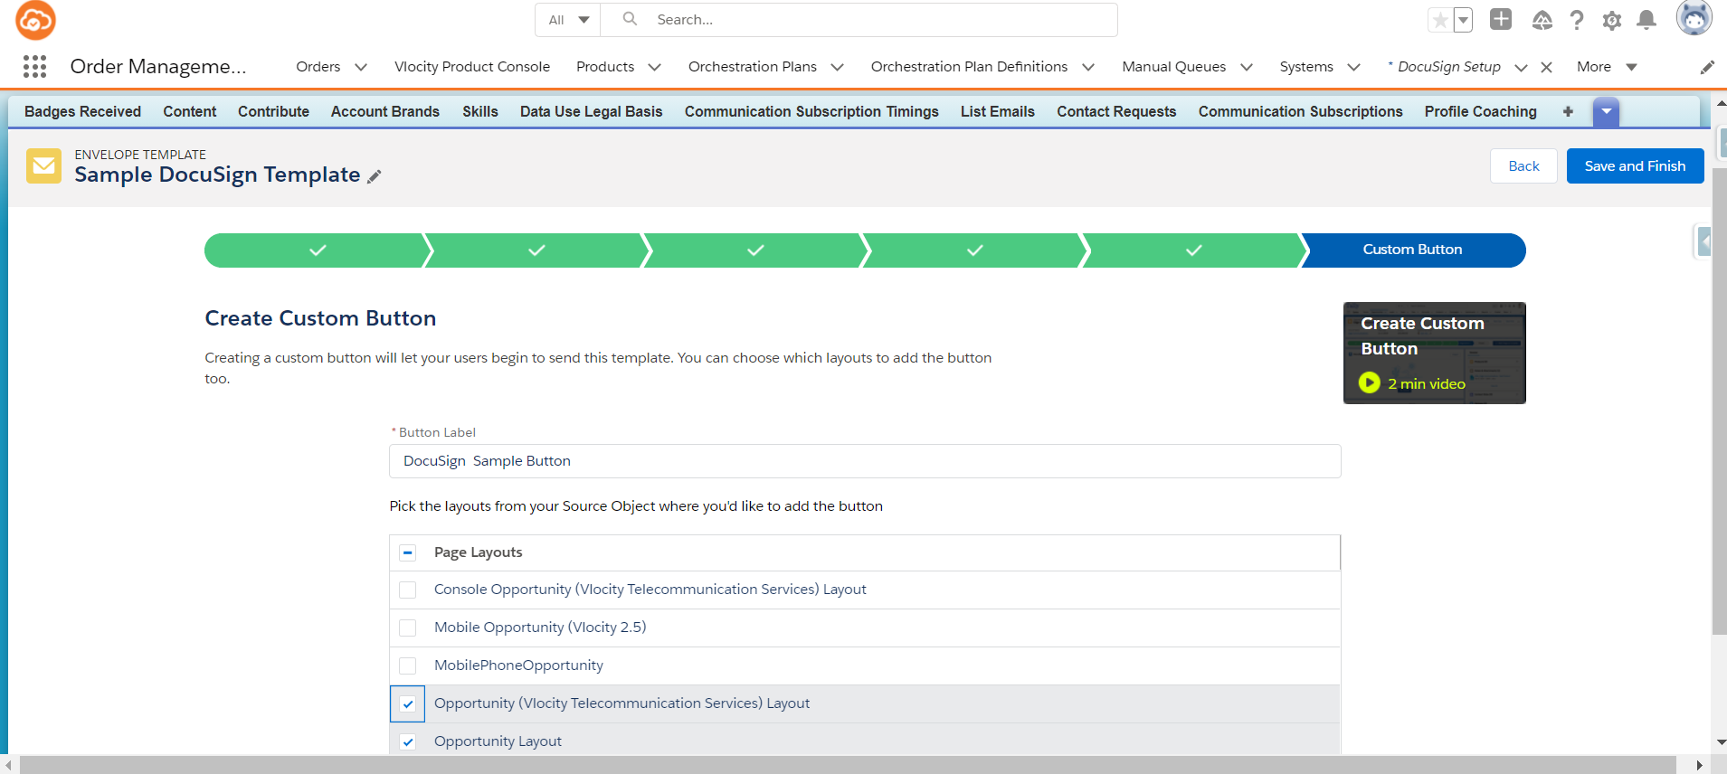

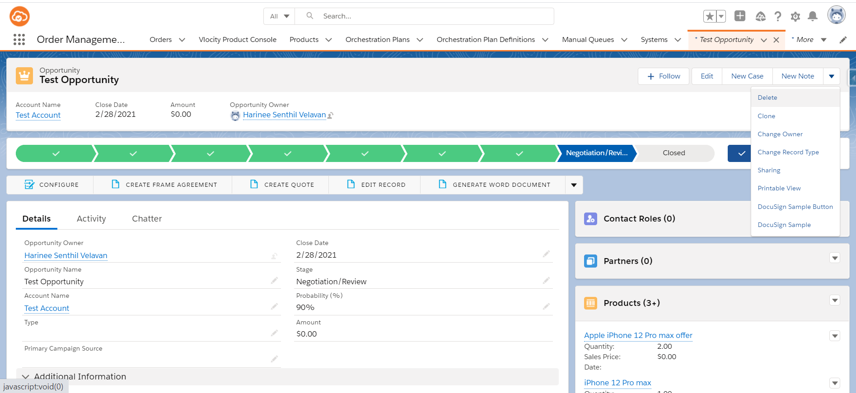

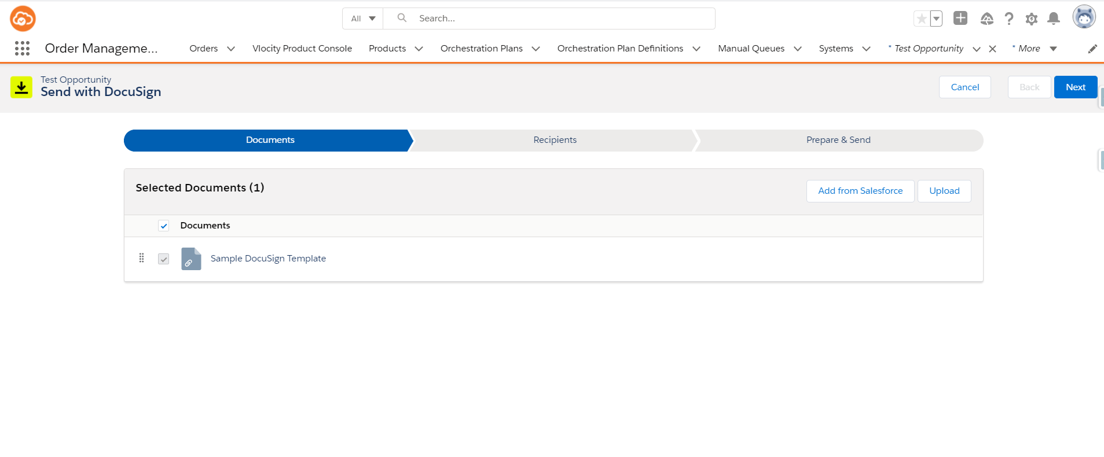

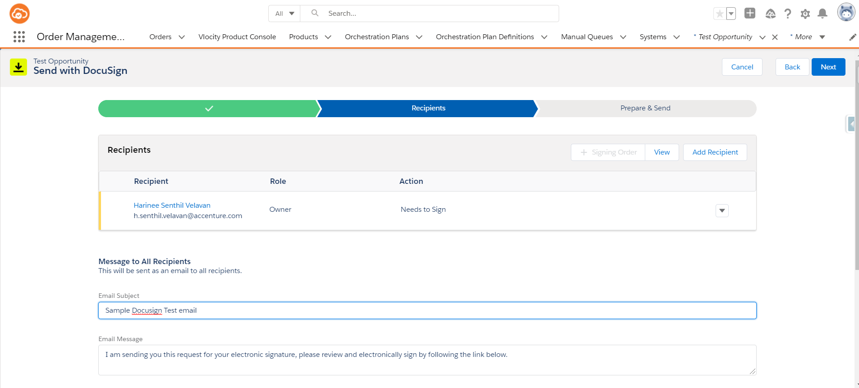

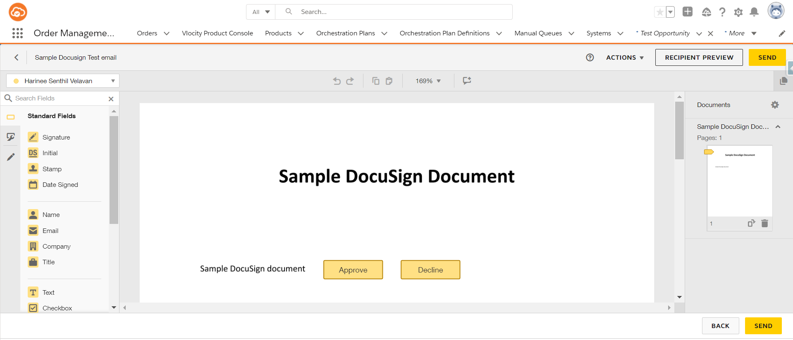

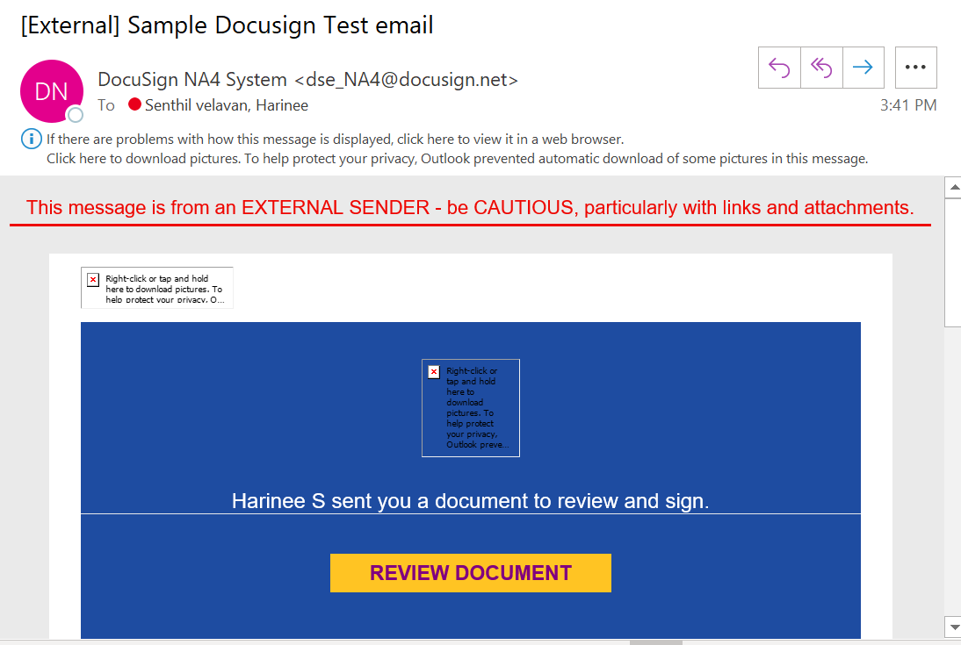

* Click on Review button

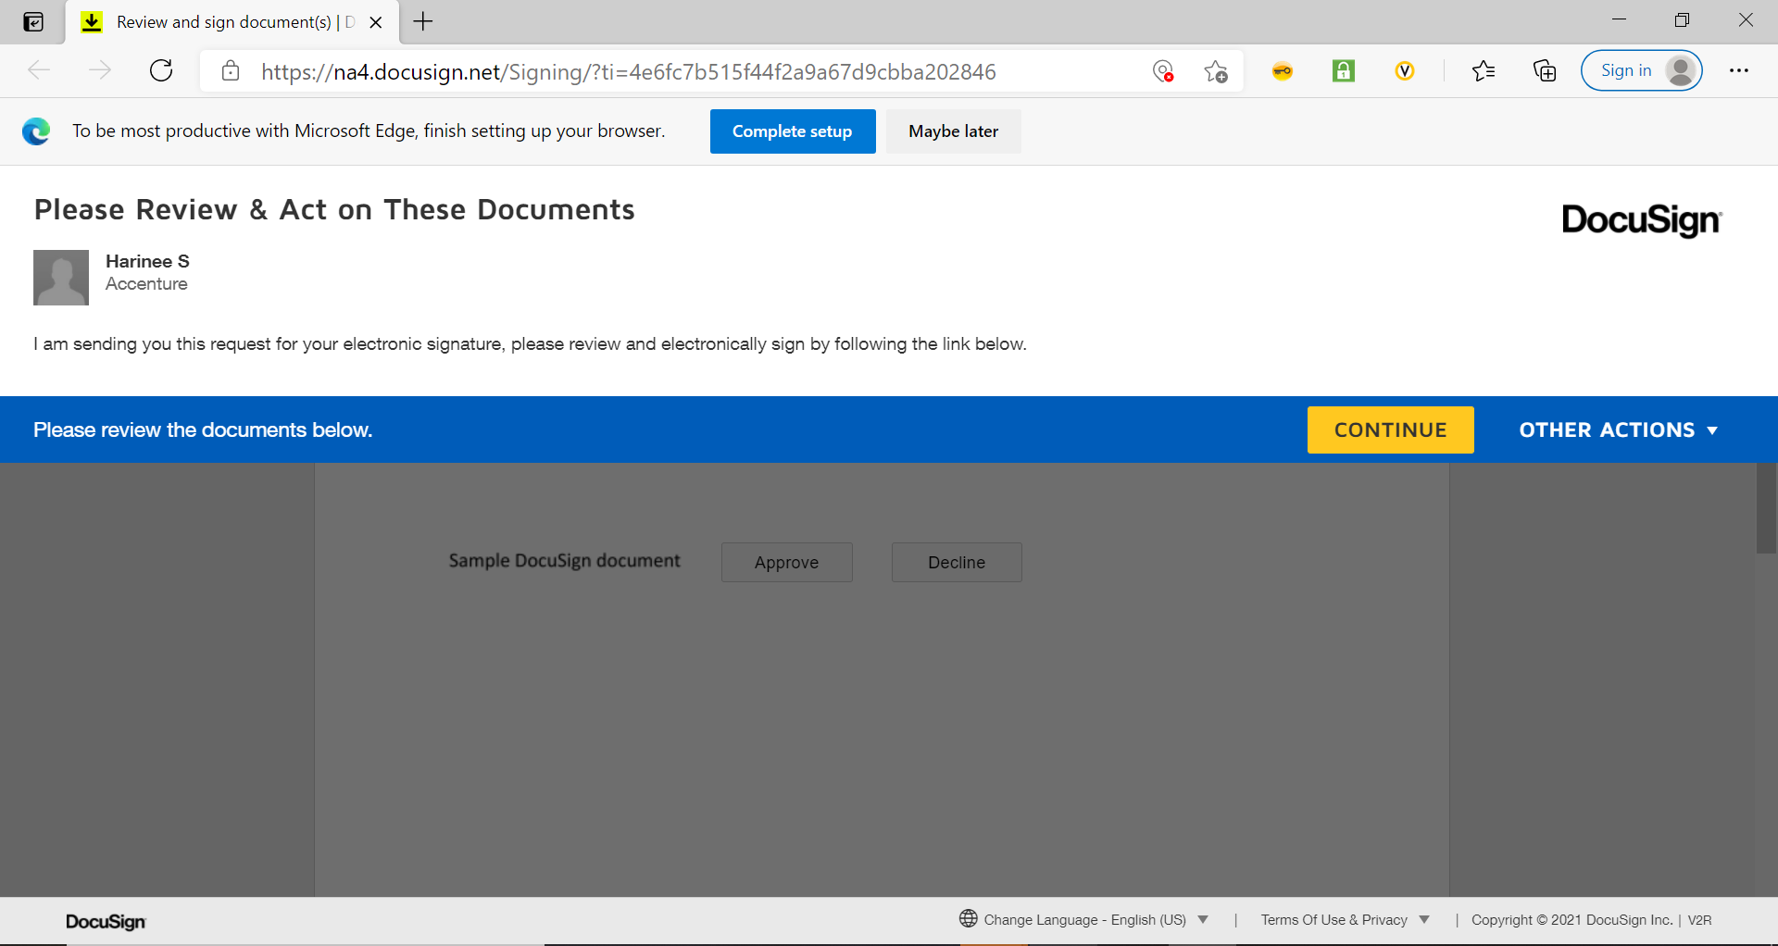

* Click on Approve button

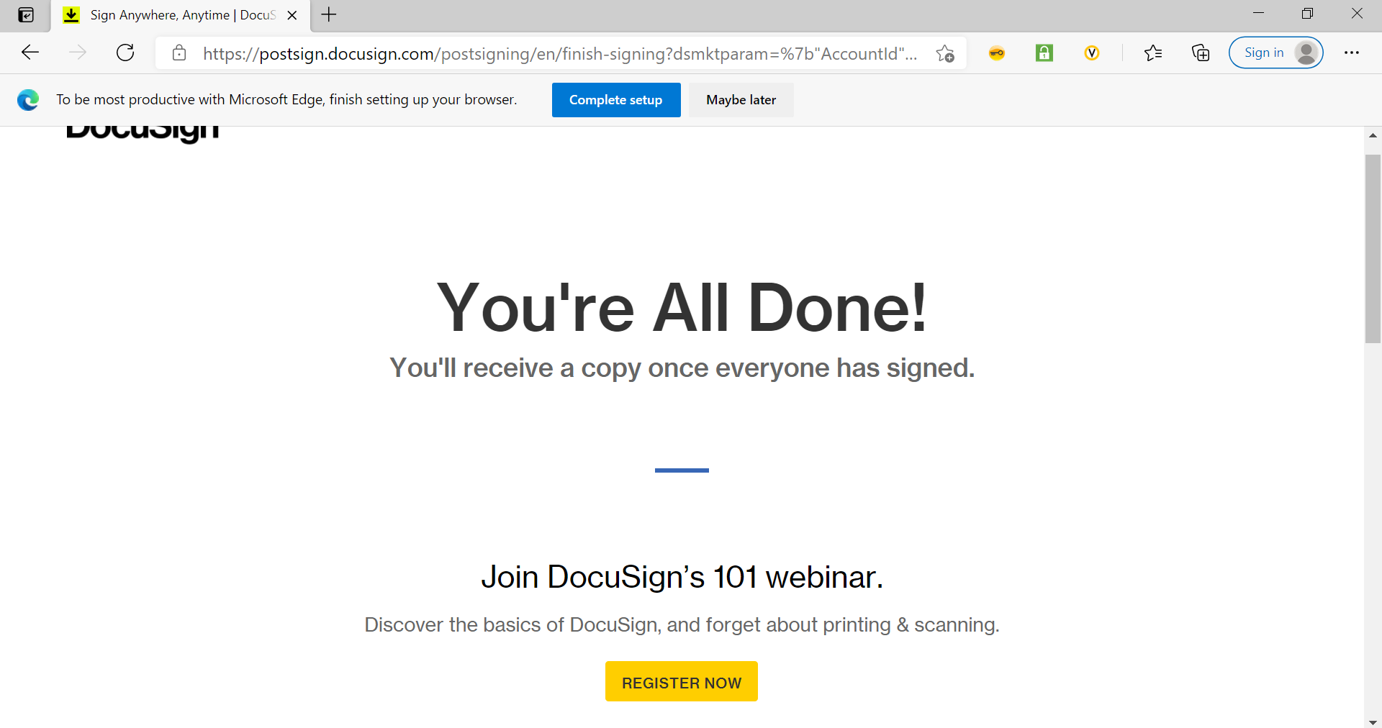

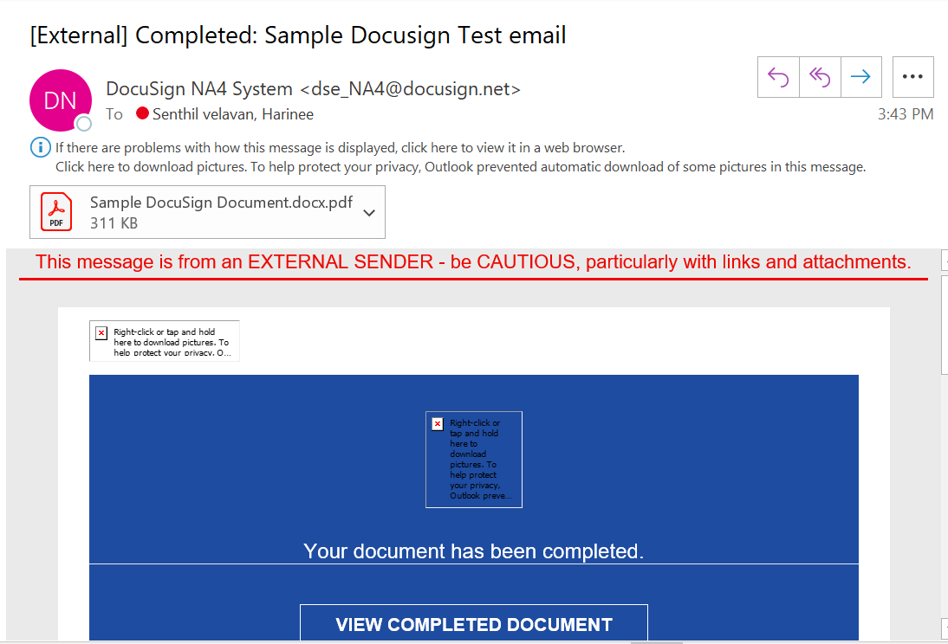

* Click on Completed Document button

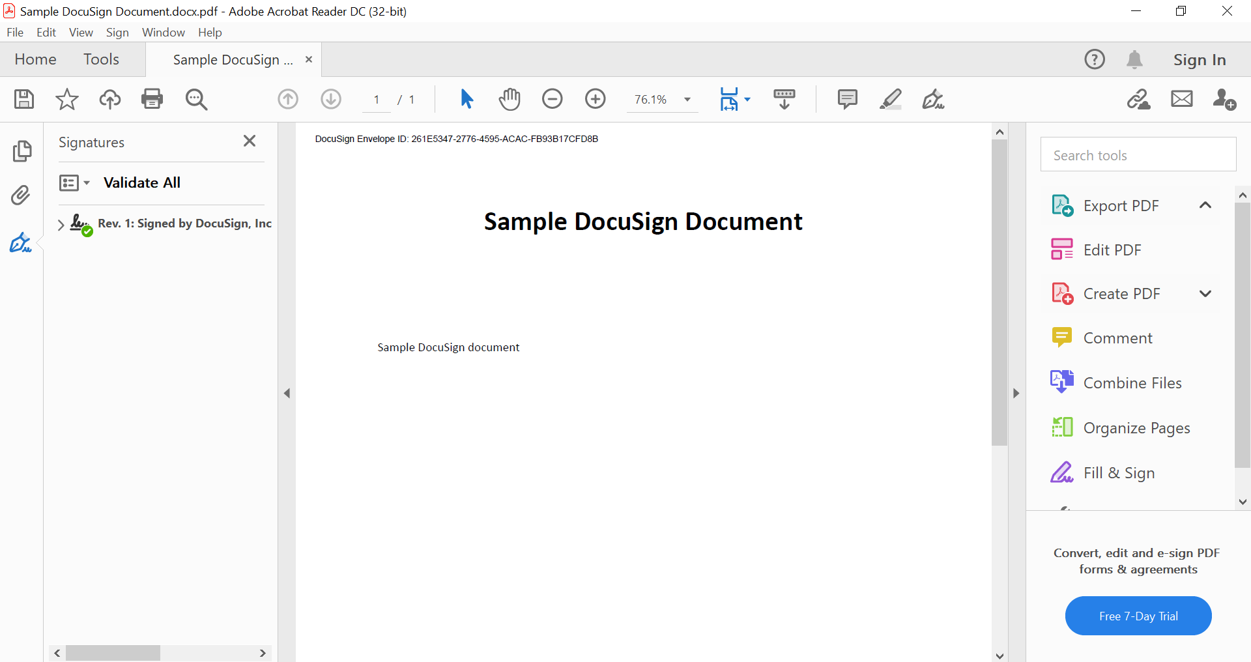

**Steps to Follow once you’re done Configuring the Template:**

1. Create the Opportunity and update the contact in the Primary Contact field.
2. Click on save.



1. Click on arrow dropdown and click on Docusign Sample Button(Custom Button) highlighted in yellow.
2. It will trigger the action and the email will be sent to the email id which was updated in the primary contact.
3. Once the recipient review the document and accept it, the custom field (Approved Status) will get updated automatically to Approved and the stage will get updated to “Got Sign off”.

**Reference links:**

[**https://www.mstsolutions.com/technical/docusign-integration-with-salesforce-using-api/**](https://www.mstsolutions.com/technical/docusign-integration-with-salesforce-using-api/)

[**https://docs.vlocity.com/en/OmniScript-Action-Components.html**](https://docs.vlocity.com/en/OmniScript-Action-Components.html)

[**https://docs.vlocity.com/en/DocuSign-Envelope-Action-Properties.html**](https://docs.vlocity.com/en/DocuSign-Envelope-Action-Properties.html)

[**https://docs.vlocity.com/en/Integrating-DocuSign-with-OmniScript.html**](https://docs.vlocity.com/en/Integrating-DocuSign-with-OmniScript.html)

[**https://docs.vlocity.com/en/Preparing-DocuSign-Documents.html**](https://docs.vlocity.com/en/Preparing-DocuSign-Documents.html)

[**https://docs.vlocity.com/en/Linking-Your-Salesforce-Org-to-Your-DocuSign-Account.html**](https://docs.vlocity.com/en/Linking-Your-Salesforce-Org-to-Your-DocuSign-Account.html)

[**https://docs.vlocity.com/en/Using-the-DocuSign-Envelope-Action-to-Email-Documents-for-Signature.html**](https://docs.vlocity.com/en/Using-the-DocuSign-Envelope-Action-to-Email-Documents-for-Signature.html)

[**https://success.vlocity.com/s/question/0D51N00004txbqnSAA/retrieve-docusign-fields-information**](https://success.vlocity.com/s/question/0D51N00004txbqnSAA/retrieve-docusign-fields-information)

